Project Design Phase-II
Technology Stack (Architecture & Stack)

Date | 26-11-2025
Name | Yakshagaraj A G
Project Name | Online Bookstore
Maximum Marks | 4 Marks

Technical Architecture:
The Online Bookstore platform follows a robust and scalable 3-tier architecture, ensuring a smooth user experience for browsing, searching, and purchasing books.
Presentation Layer (Frontend)
- User-friendly interface for browsing, searching, and purchasing books
- Responsive design for desktop and mobile
- Provides separate admin UI for book management

Application Layer (Backend / Business Logic)
- Handles user authentication, book search, cart operations, orders, and admin controls
- REST APIs for the frontend
- Secure processing of order data

Data Layer (Database)
- Stores users, books, categories, cart items, orders, and reviews
- Ensures consistent and safe storage of all platform data

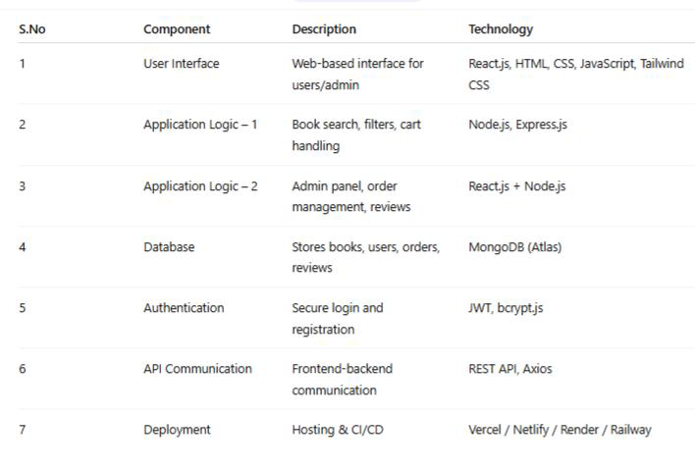
Table-1 : Components & Technologies:

Table-2: Application Characteristics:
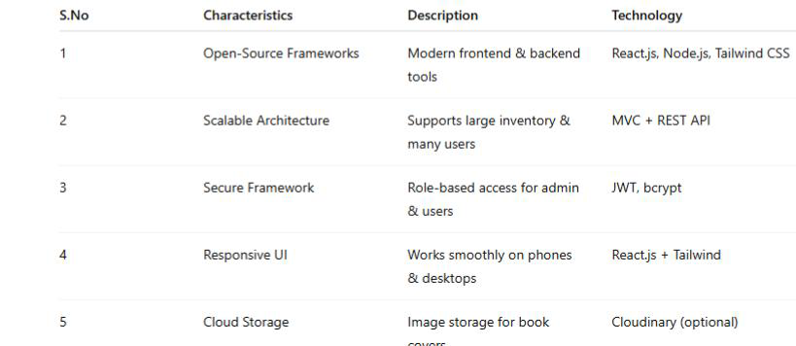
References:
React.js Documentation
Node js Best Practice
JSON Web Server Referance

